**Code Guide**

1. This code is based on the paper : M. Abdollahifard, K. Faez, M. Pourfard, M. Abdollahi, “[A Histogram-based Segmentation Method for Characterization of Self-assembled Hexagonal Lattices](https://www.sciencedirect.com/science/article/pii/S0169433211010282),” Applied Surface Science, vol. 257 pp. 10443-10450, 2011 [**IF=6.182****] [**[**Q1**](https://www.scimagojr.com/journalsearch.php?q=28983&tip=sid&clean=0)**] [**[**PDF**](https://www.researchgate.net/publication/251528997_A_histogram-based_segmentation_method_for_characterization_of_self-assembled_hexagonal_lattices?_sg%5B0%5D=qBhIGb8uzW3v-7l_VLPS5uJOxy5AJStk4vDgSBOgxLmidPjNLpZNsfAPCi3CXZlwUpiV1s9p-uNx9o6TIuHOUMi71tvbqIKv85t_CIwR.vg4gVMF4RZjSq0AdEyPvoT5cD0YaWgBUJHxb1N1tP-FnEyWiN40fw8-s37QpfMyT2iV3YGufQjVjbvrF3bGQ8g)**]**.

If you have used the code you must cite the above paper.

Code Language: MATLAB

Date of code: 2012

Producer: Mohammadreza Javad Abdollahifard with Mohammadreza Pourfard modification

Email: [pourfardm@gmail.com](mailto:pourfardm@gmail.com)

**How to run the code?**

1. Run the guide command in matlab
2. select browse button to choose the image (e.g. 1-1-2-.tif)
3. Press run angular triangulation button

this file use these matlab files: imerg.m, myangle4.m, myspreading.m, peakfind.m, triangulation_ab.m, adaptivethresh4.m

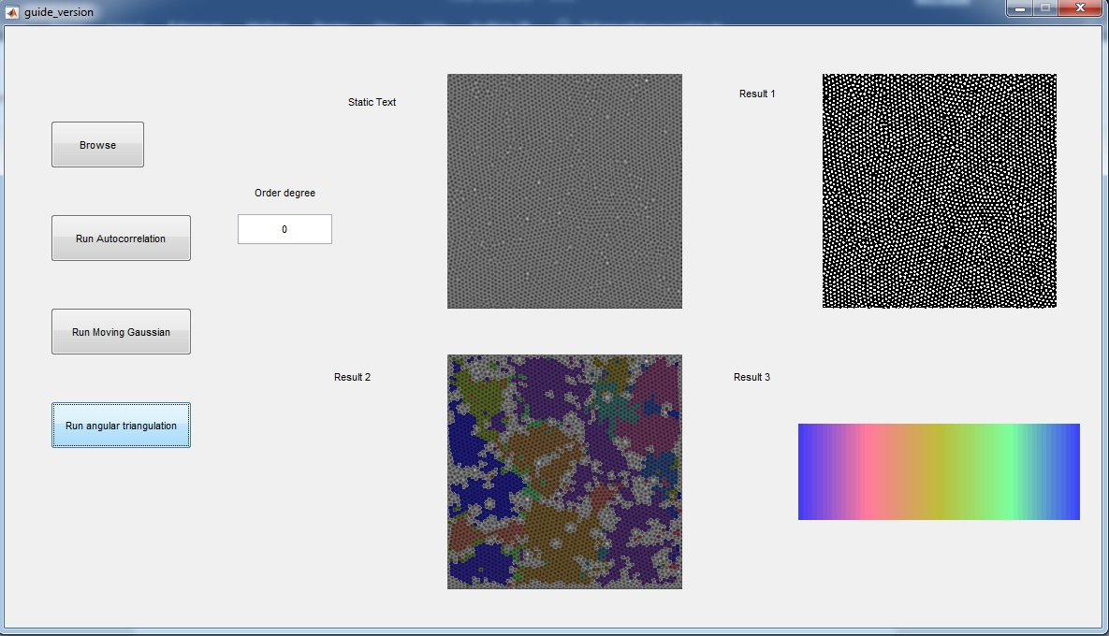

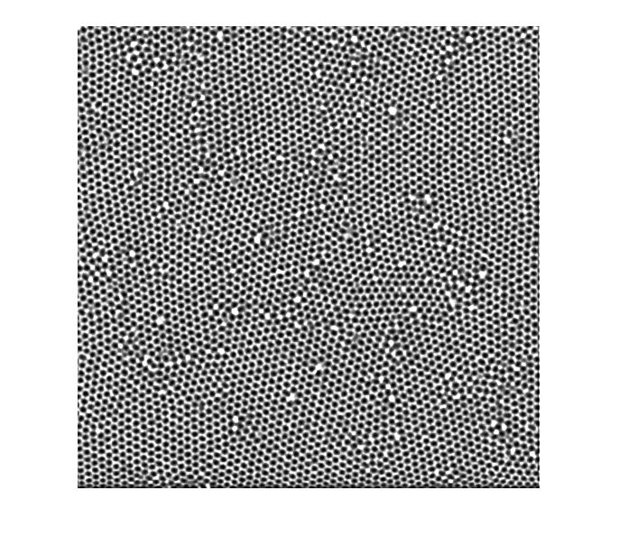

Figure 1 is original image.

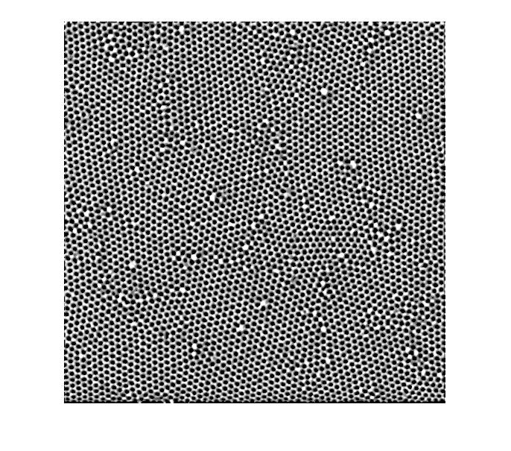

figure 2 is the result of pre-processing and adaptive thresholding (similar gray-level in whole image)

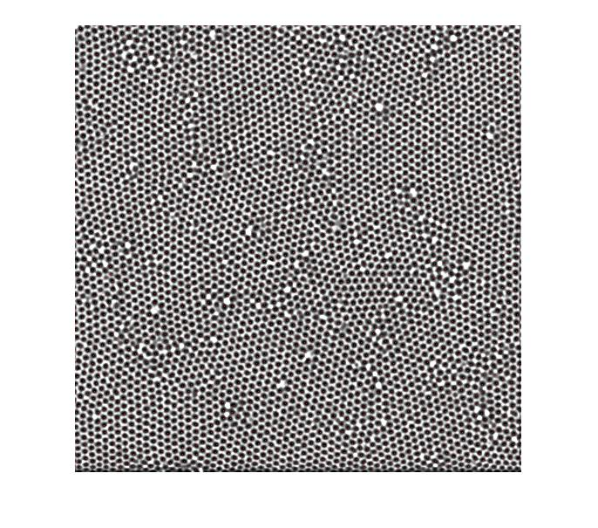

Figure 3 shows the pore’s center in red

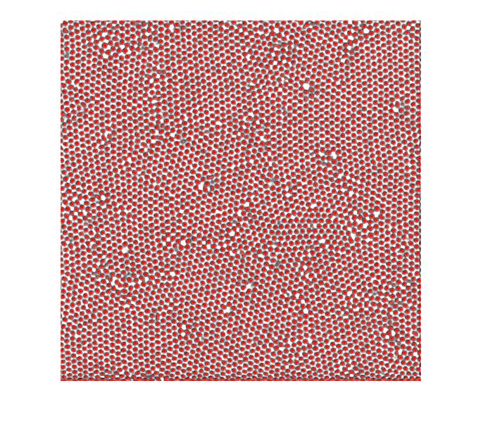

figure 4 show the pores

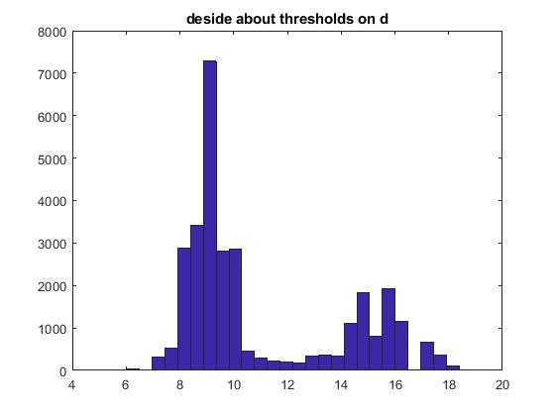

figure 5 show the orientations of the pores

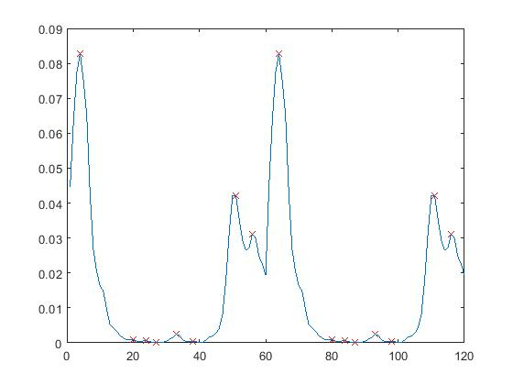

Figure 6 has smoothed the histogram with hamming window and defined the peaks and valleys of the mountain based on fuzzy logic. It let the histogram cut based on the valleys.

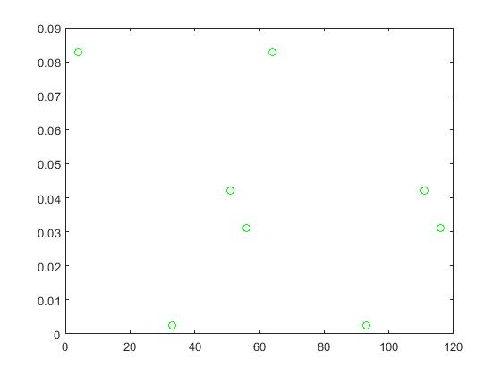

Figure 7

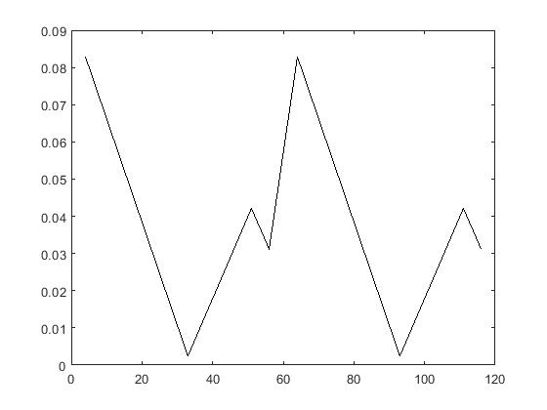

Figure 8

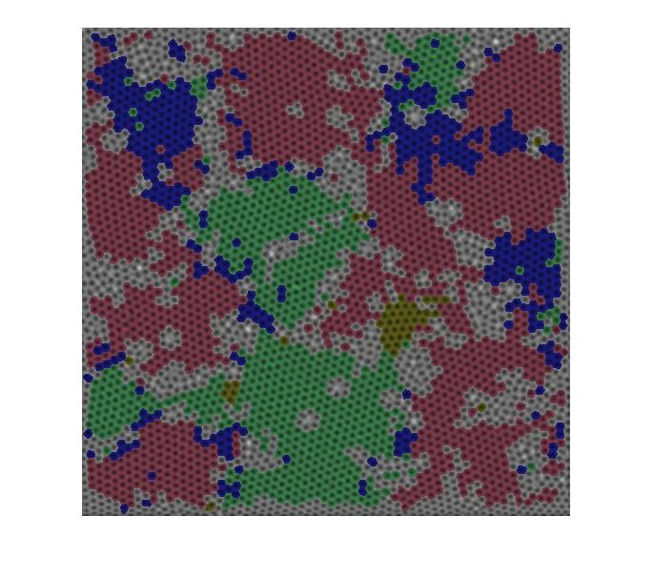

Figure 9 shows the pore orientation in fuzzy color (the same orientation has the same color while although they are in different positions of the image)



Figure 10

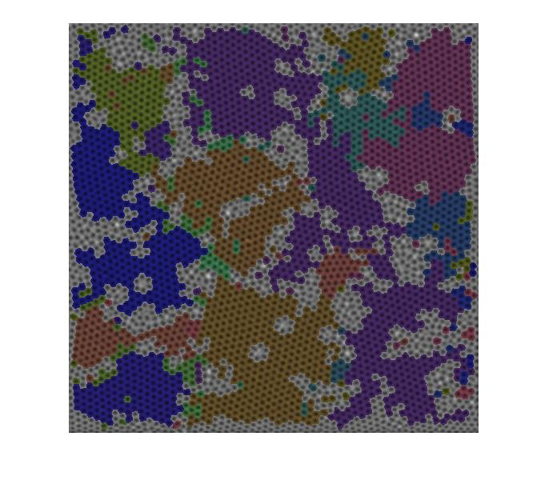

Figure 11 shows the neighborhood region with the same color and it does local segmentation. The it defines the largest domain

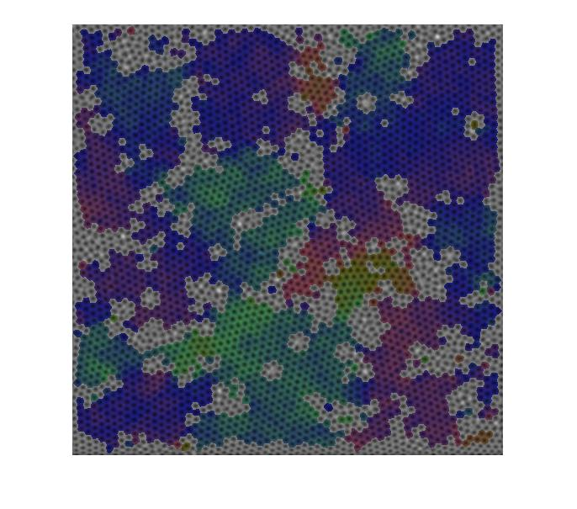



Figure 12 shows the regions based on their orientations and the color smoothly differs with small differ in orientation